TRIBHUVAN UNIVERSITY
PATAN MULTIPLE CAMPUS
PATANDHOKA, LALITPUR

DATABASE ADMINISTRATION (BIT 352)

SUBMITTED BY: | SUBMITTED TO:
NAME: SURESH DAHAL | BIPIN TIMALSINA
ROLL: 23
CLASS: BIT-III/II | ___________________
DATE: 2083/04/22 | CHECKED BY

11. Working With RMAN Backup and Recovery
OUTPUT
a) Preparation and Configuration for Backup
Step 1: Connect as SYSDBA
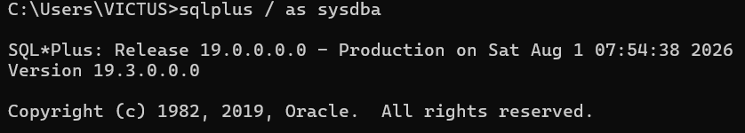
Step 2: Check whether the database is in ARCHIVELOG mode
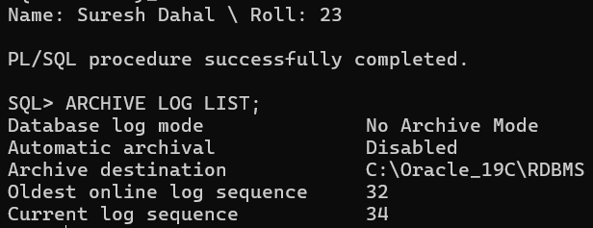
Step 3: Enable ARCHIVELOG mode
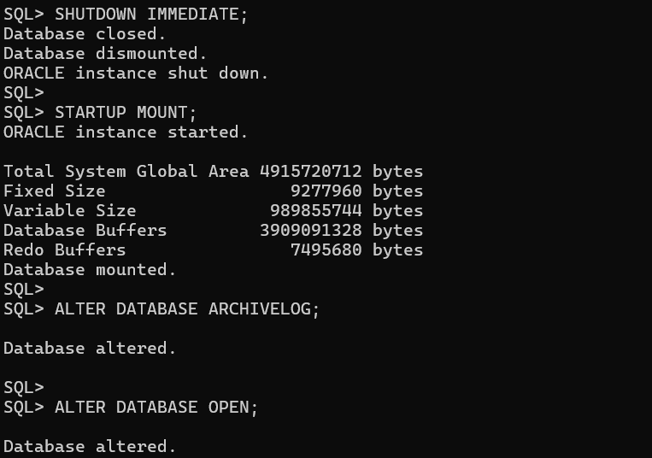
Step 4: Check Fast Recovery Area (FRA)
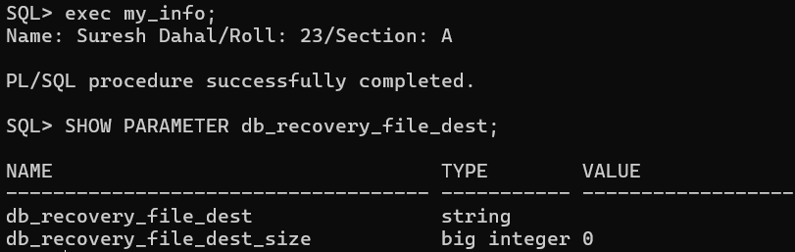
Step 5: Connect to RMAN
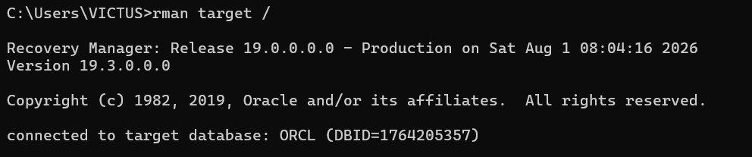
Step 6: Display current RMAN configuration
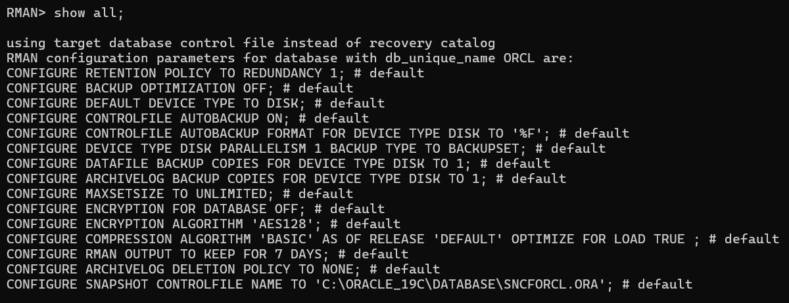
Step 7: Enable Control File Autobackup
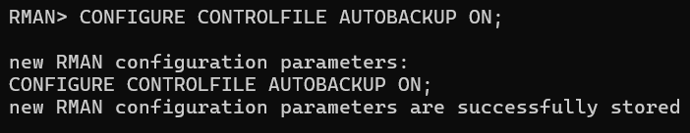
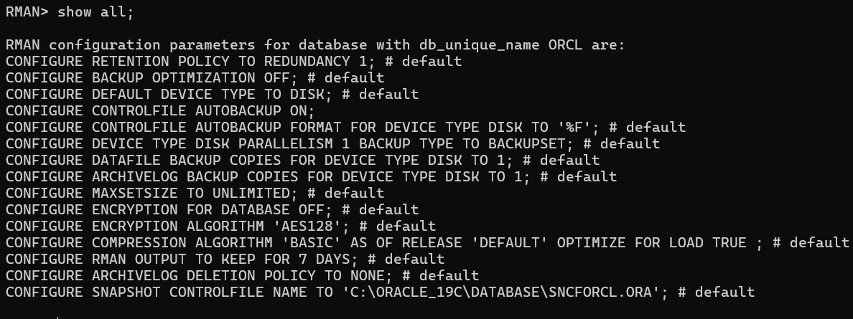

b) Perform Full Backup
Step 1: Backup the entire database including archived redo logs
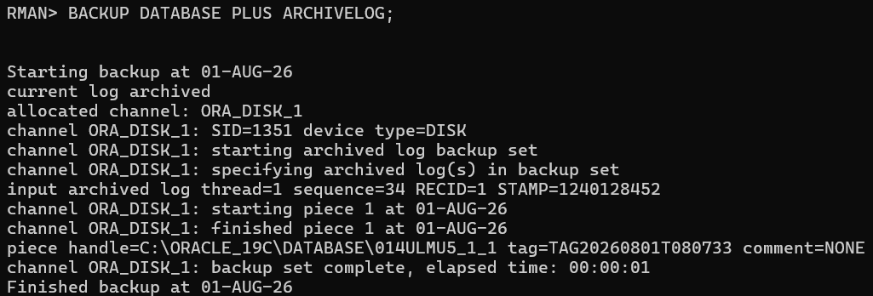
Step 2: Verify backup
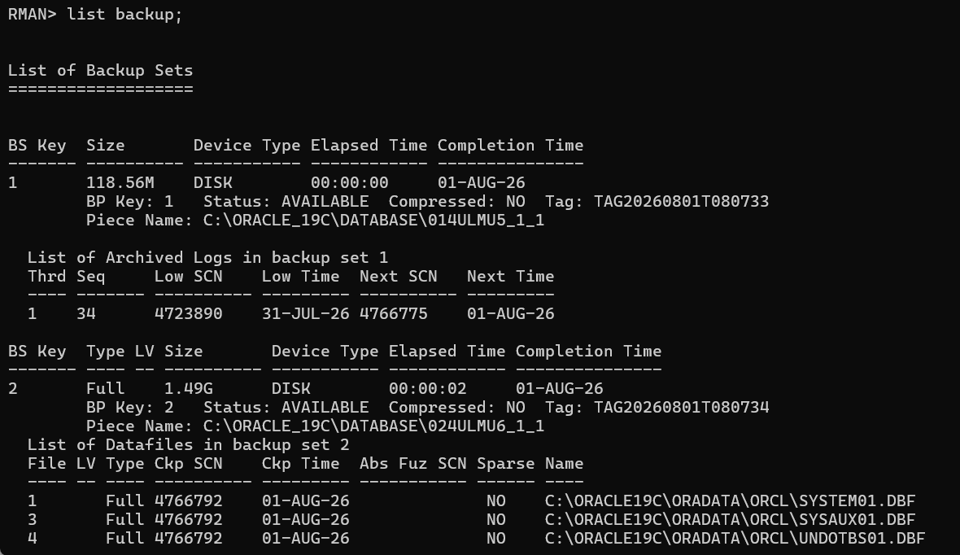
c) Simulate Database Failure
Step 1: Find the USERS datafile
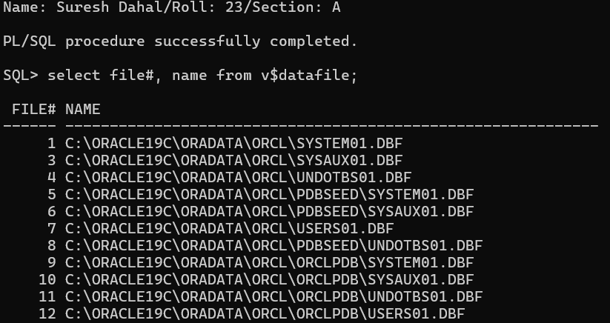
Step 2: Shutdown database
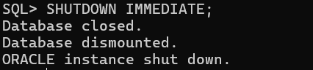
Step 3: Delete the USERS datafile
Step 4: Switch to OCRLPDB and open database
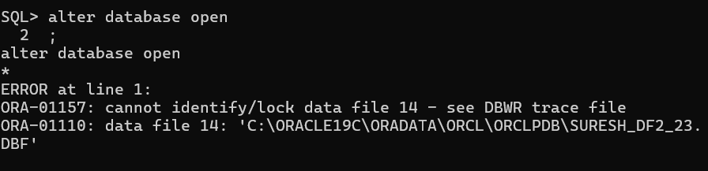
d) Restore and Recover the Datafile
Step 1: Connect to RMAN
rman target /
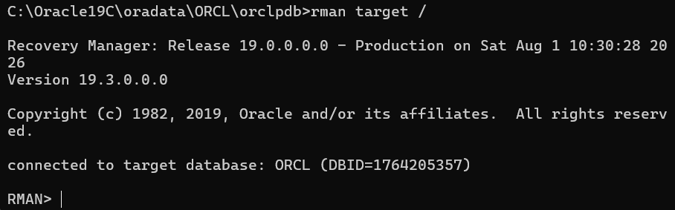
Step 2: Restore the datafile
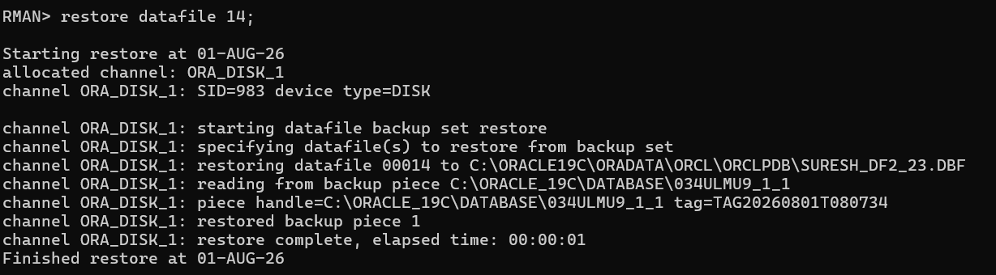
Step 3: Recover the datafile
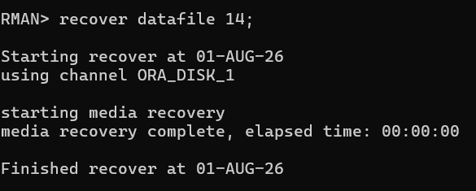
Step 4: Verify
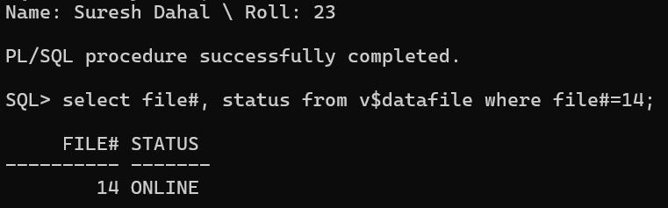
e) Full Database Recovery Simulation
Step 1: Shutdown database
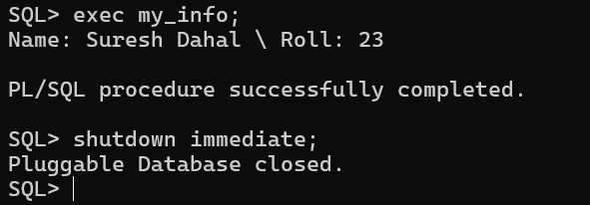
Step 2: Delete the SPFILE, control files and datafiles
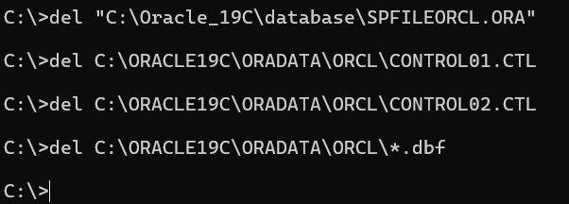
Step 3: Connect RMAN
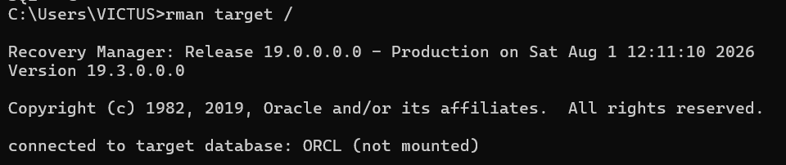
Step 4: Restore SPFILE
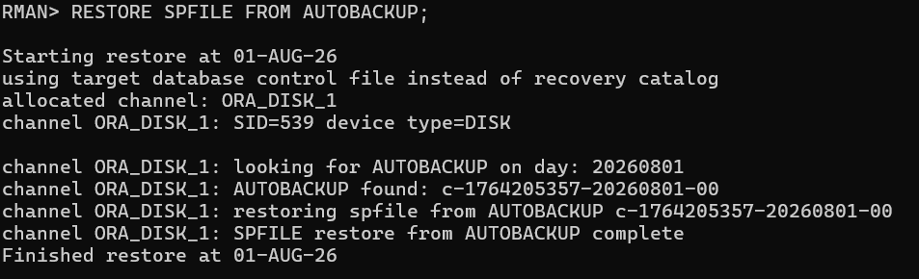
Step 5: Restore control file
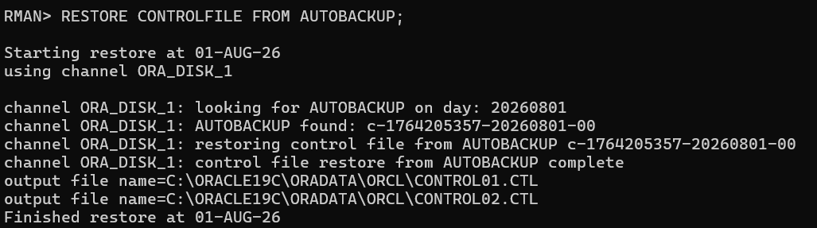
Step 6: Restore database
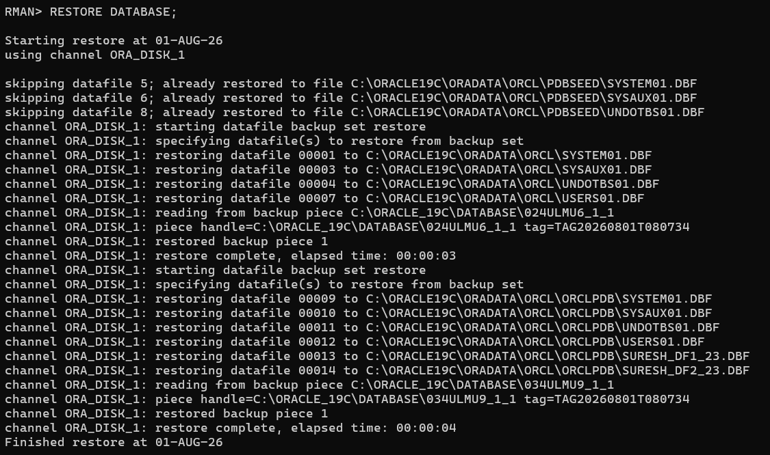
Step 7: Recover database
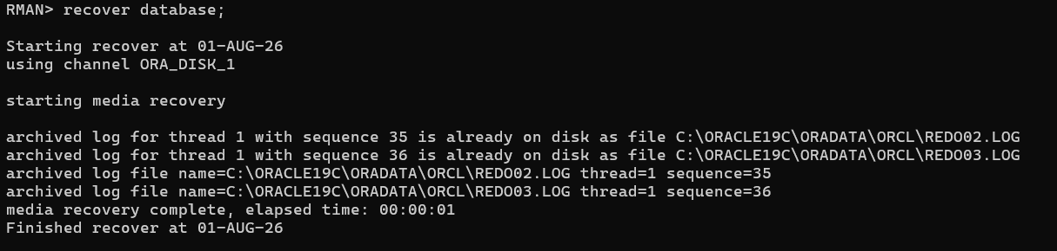
Step 8: Open database
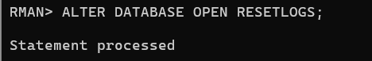
f) Validation and Cleanup
Step 1: Validate database
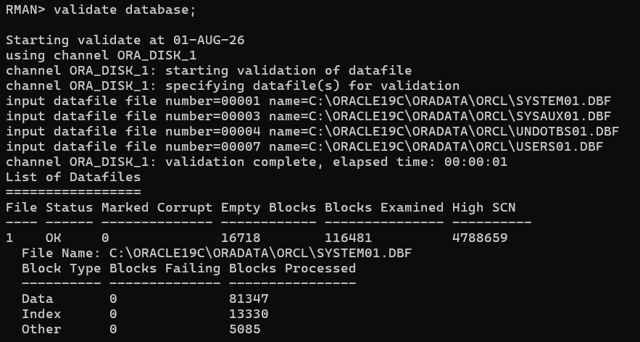
Step 2: Check corruption
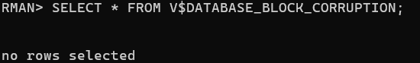
Step 3: Verify data
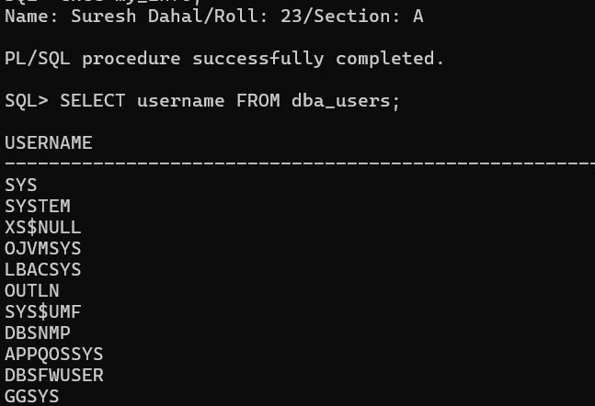

12. LEARNING ABOUT STANDARD AUDITING IN ORACLE
OUTPUT
(a) Preparation and Configuration for Standard Auditing
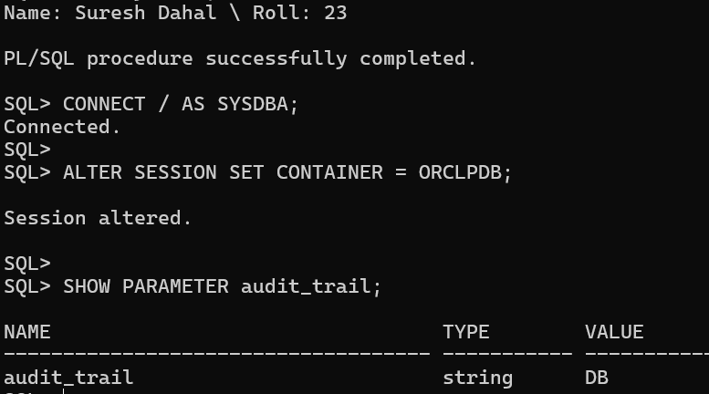
(b) Enable Auditing
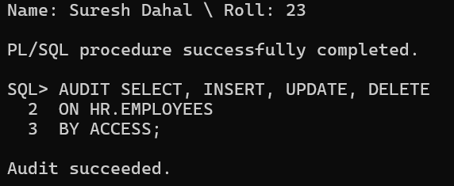
(c) Generate Audit Records
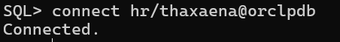
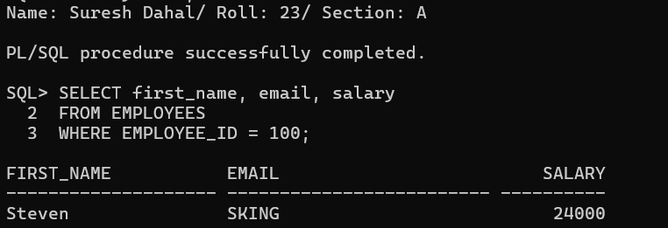
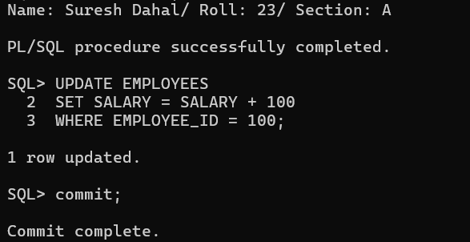
(d) Query and Analyze Audit Trail
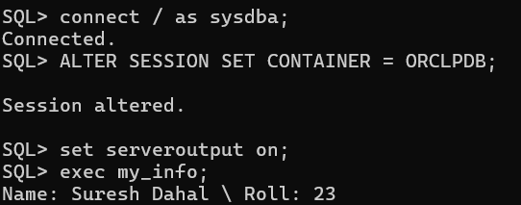
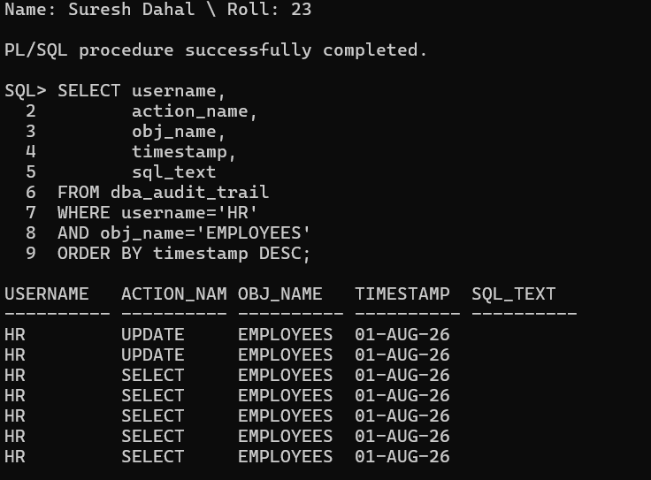
(e) Disable Auditing and Purge Audit Trail
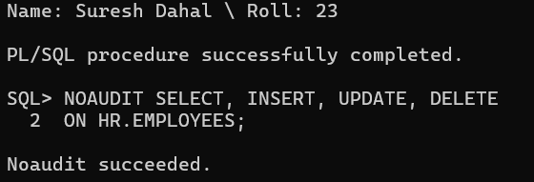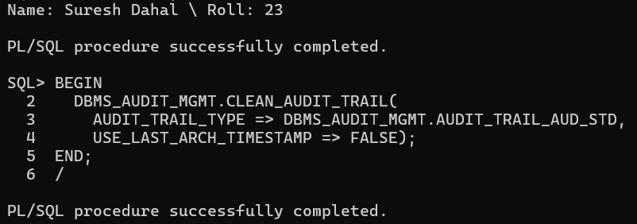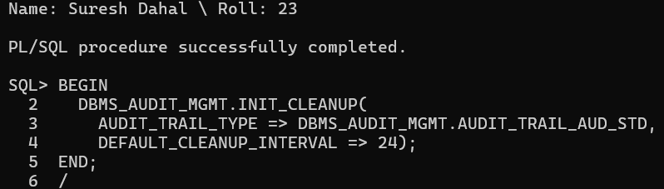

(f) Validation
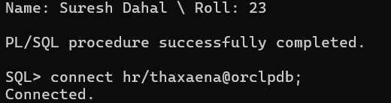
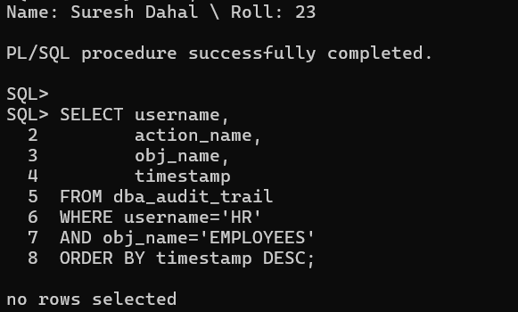

13. WORKING WITH UNIFIED AUDITING IN ORACLE
OUTPUT
(a) Preparation and Verification
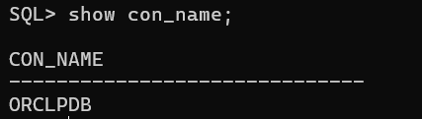
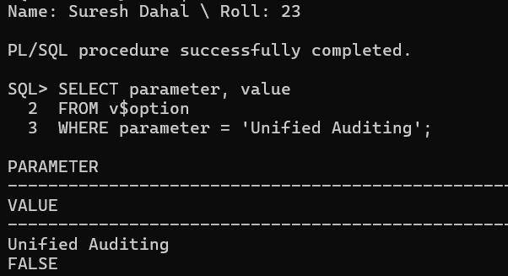
(b) Create and Enable Audit Policy
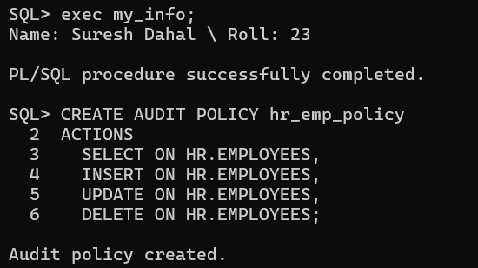
Enable the policy:
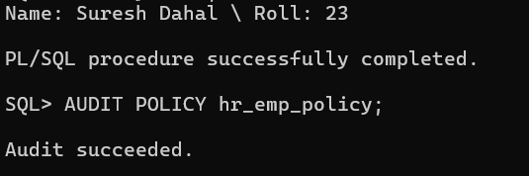
(c) Generate Audit Records
Connect as HR:
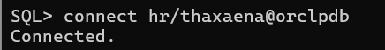
Insert a record: 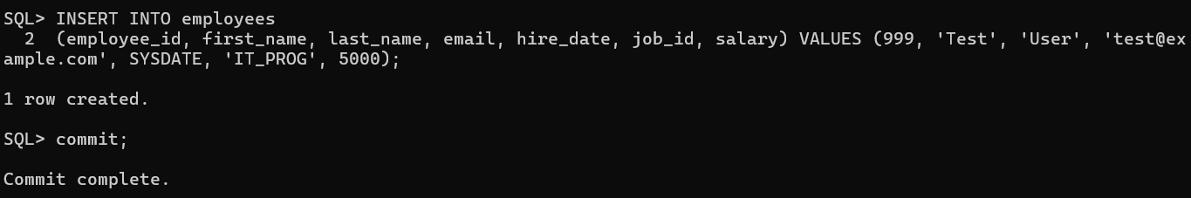
Delete the record:
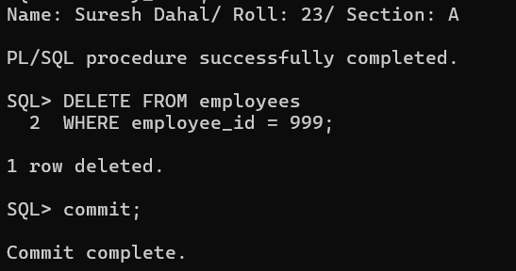
(d) Query and Analyze Unified Audit Trail
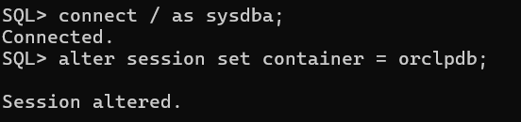
Query the audit trail:
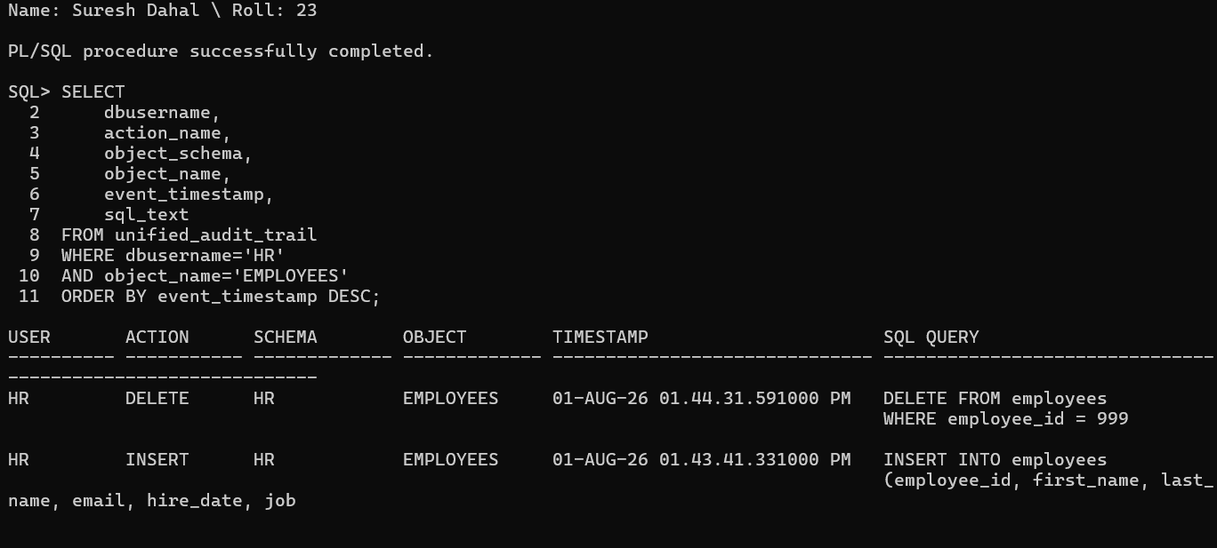
(e) Conditional Auditing
Create a conditional audit policy:
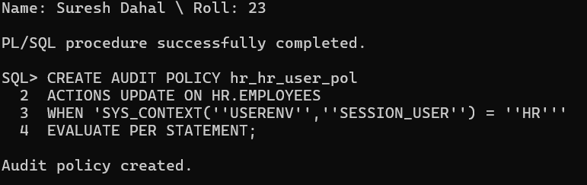
Enable it:
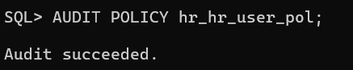
Connect as HR:
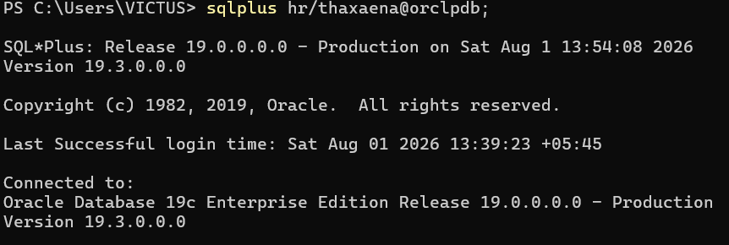
Execute a qualifying update:
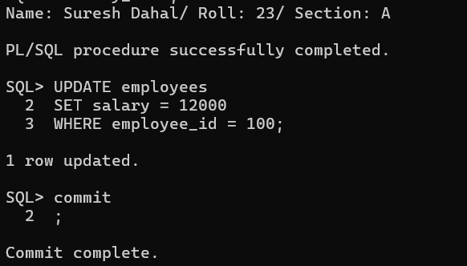
Verify the audit record:
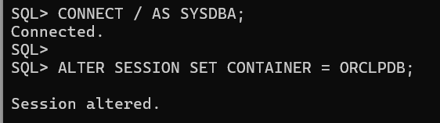
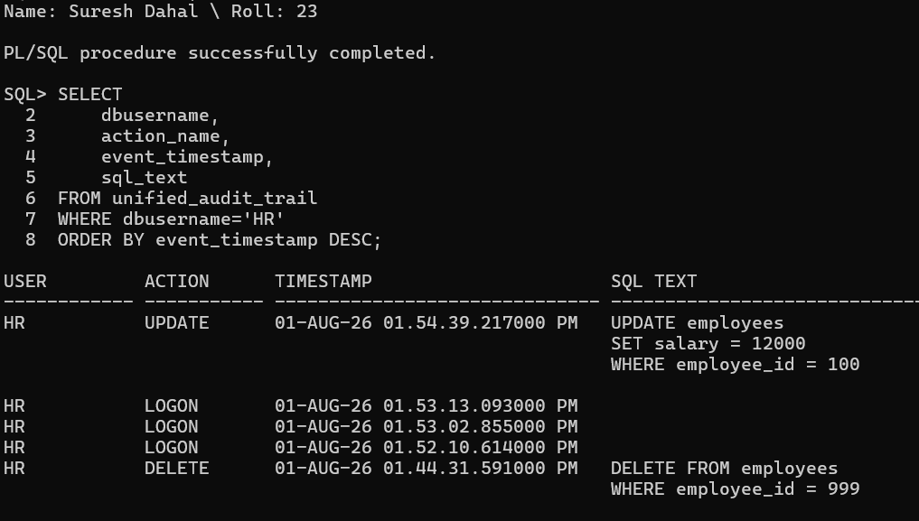
(f) Disable, Drop, and Cleanup
Disable both policies:
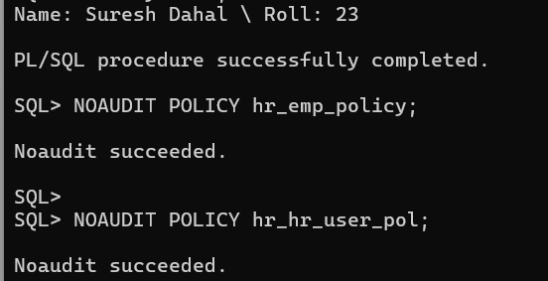
Drop them:
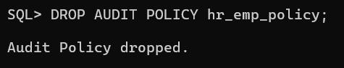
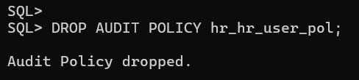
Purge the Unified Audit Trail:
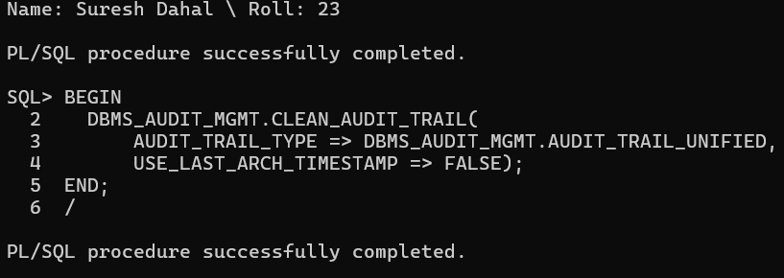
Validation:
Connect as HR:
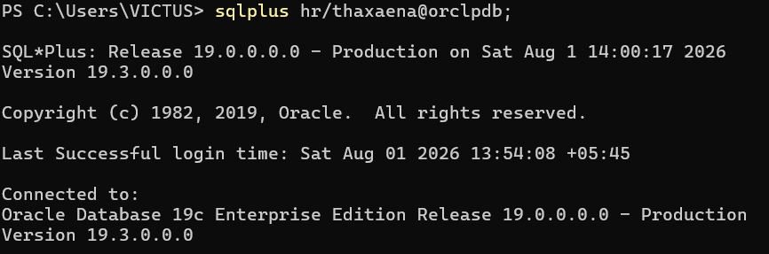
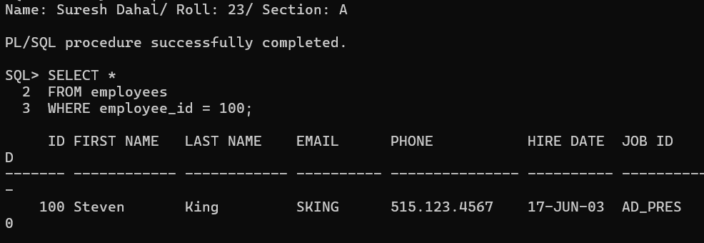
Connect as SYS:
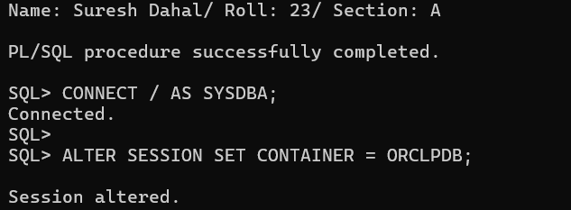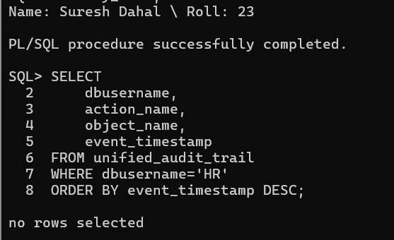

14. EXPLORING FLASHBACK TECHNOLOGY IN ORACLE.
OUTPUT
(a) Preparation and Configuration
Step 1: Connect as SYS
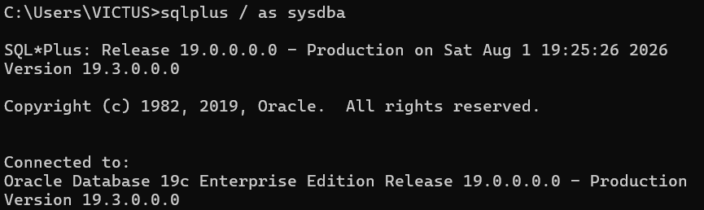
Step 2: Check UNDO_RETENTION
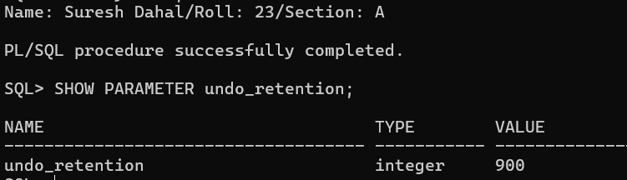
Step 3: Check Recycle Bin
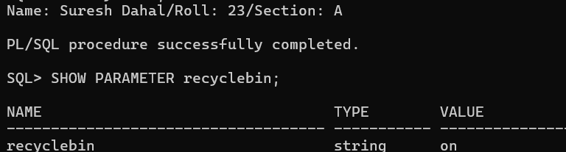
Step 4: Set UNDO_RETENTION (if less than 3600)
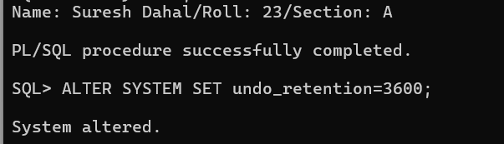
Step 5: Verify the change
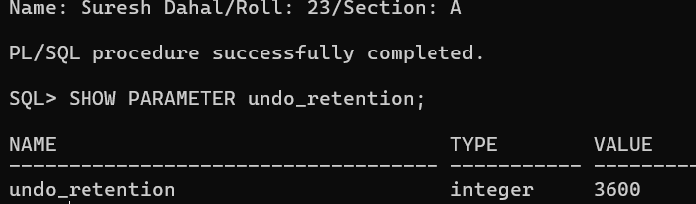
Step 6: Verify ARCHIVELOG mode
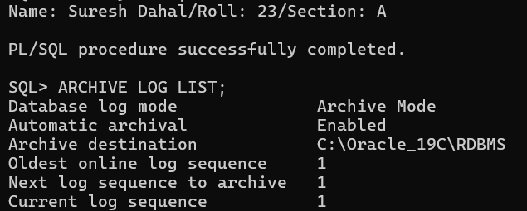
(b) Flashback Query
Step 1: Connect as HR
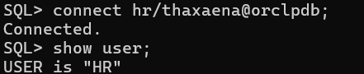
Step 2: Check current salary
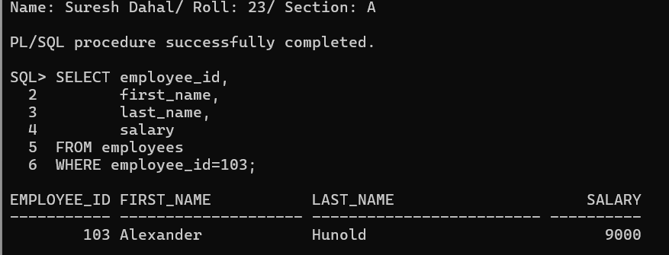
Step 3: Record current timestamp
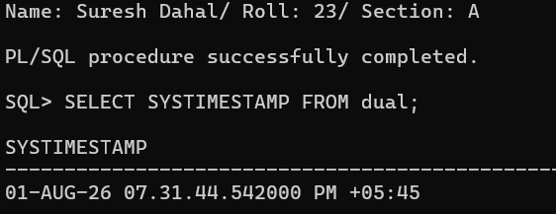
Step 4: Increase salary
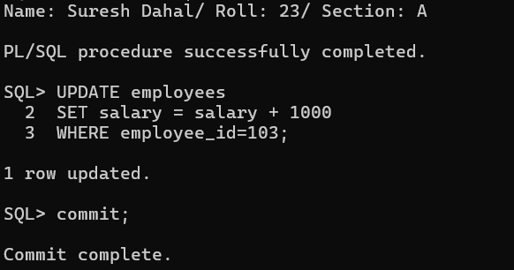

Step 5: Verify updated salary
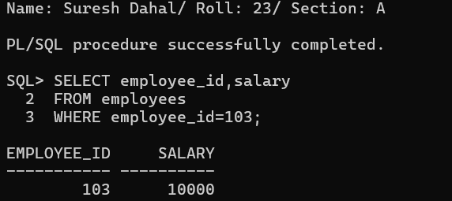
Step 6: Flashback Query
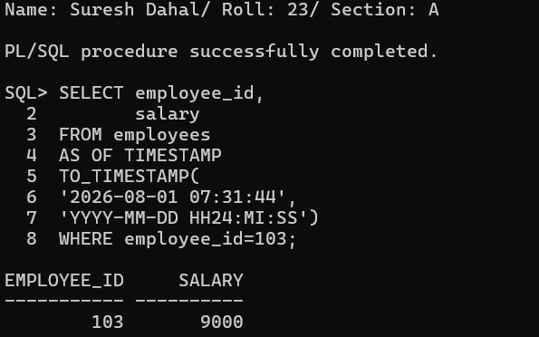
(c) Flashback Version Query
Step 1: Check salary.
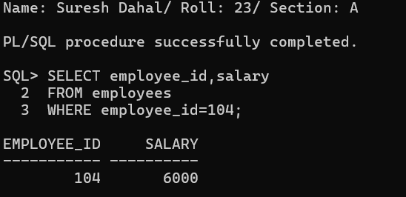
Step 2: Increase salary by 500.
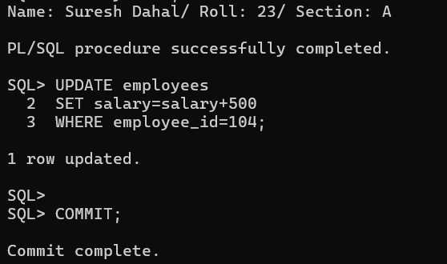
Step 3
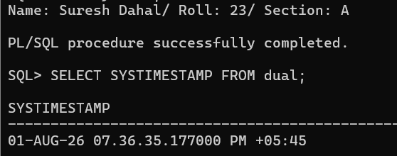
Step 4: Increase salary again.
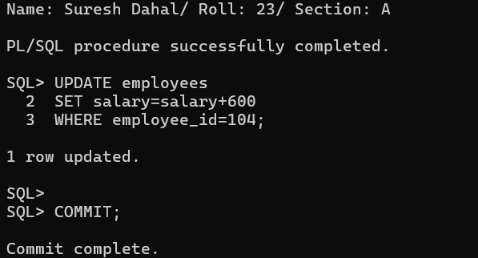
Step 5: Display all versions.
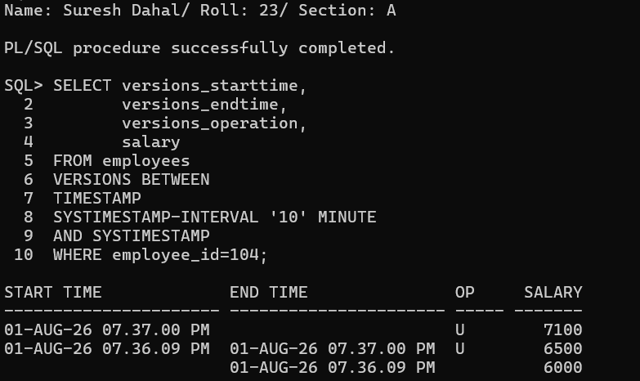
(d) Flashback Table
Step 1: Connect as sys
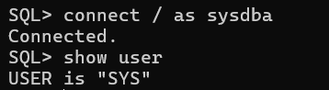
Step 2: Enable row movement.
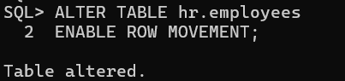
Step 3: Connect back as HR.
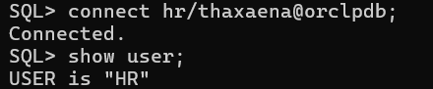
Step 4: Delete employee 105.
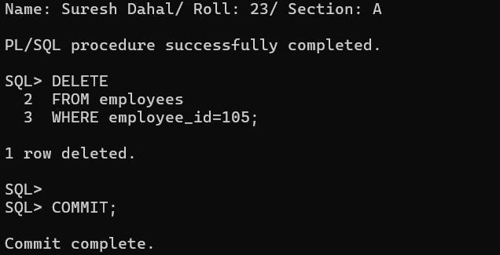
Step 5: Record timestamp.
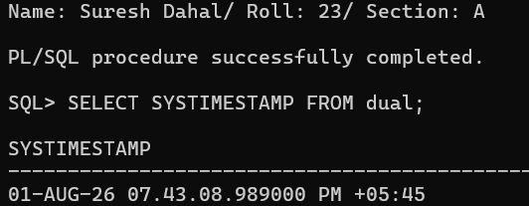
Step 6: Flashback table.
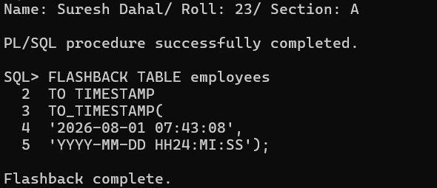
Step 7: Verify.
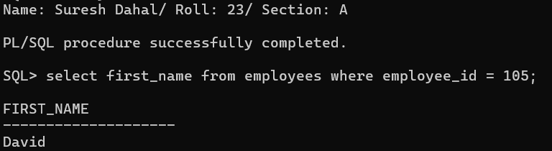
(e) Flashback Drop
Step 1: Drop table.
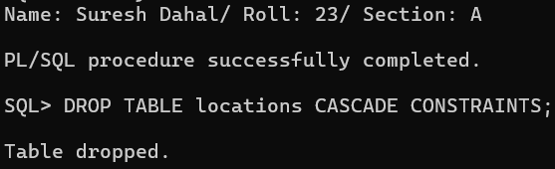
Step 2: Check the recycle bin.
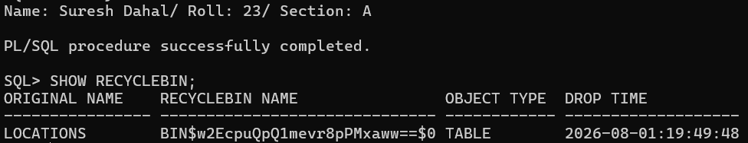
Step 3: Restore table.
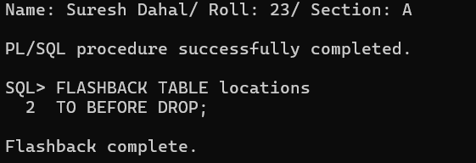
Step 4: Verify.
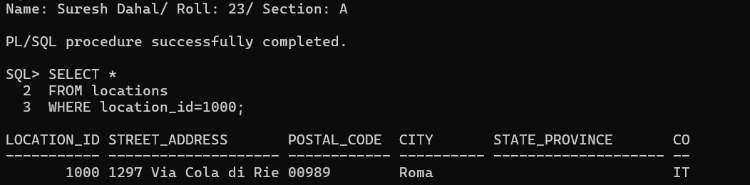
(f) Validation and Cleanup
Restore employee 103 salary
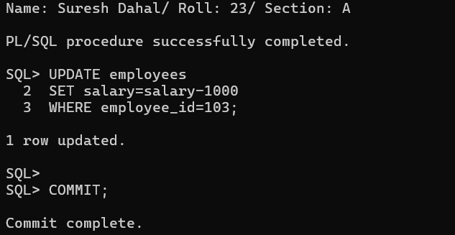
Restore employee 104 salary
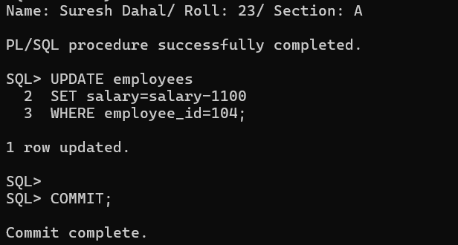
Delete employee 105 again
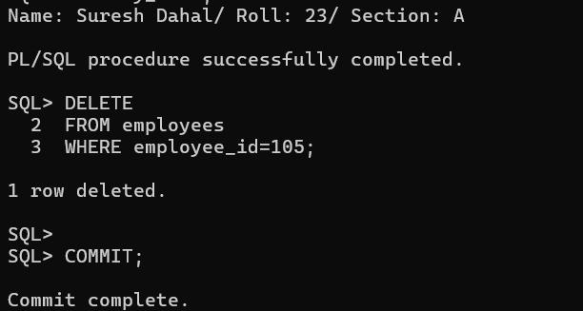
Demonstrating ORA-08180
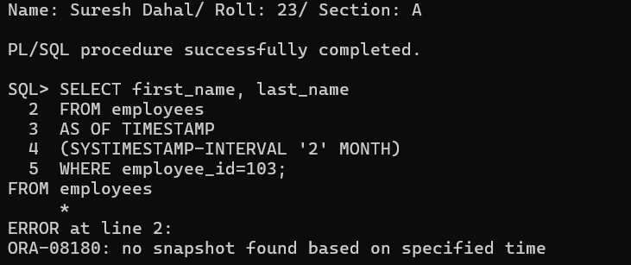

15. ORACLE FLASHBACK VERSION QUERY AND TRANSACTION QUERY
OUTPUT
(a) Preparation and Configuration
Step 1: Connect as SYSDBA
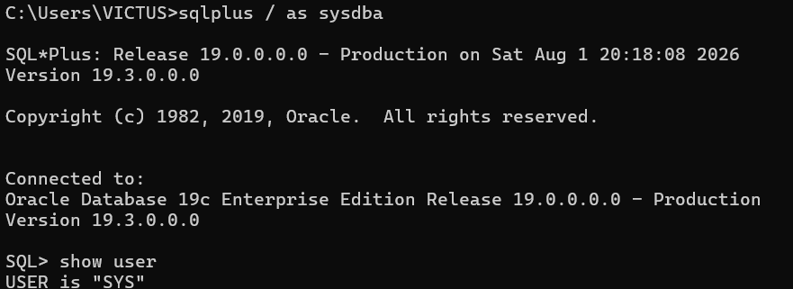
Step 2: Grant required privileges to HR
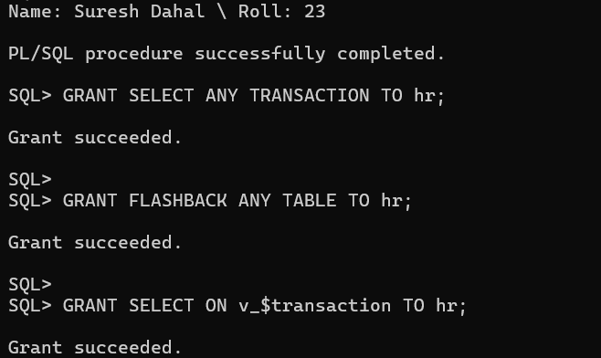
Step 3: Check UNDO retention
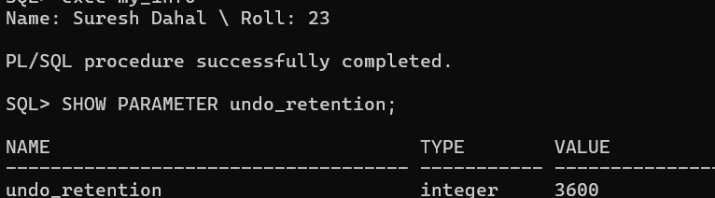
Step 4: Increase UNDO retention (if less than 7200)
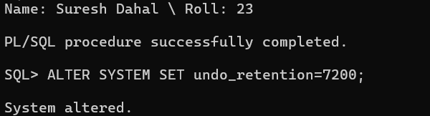
Step 5: Verify the parameter
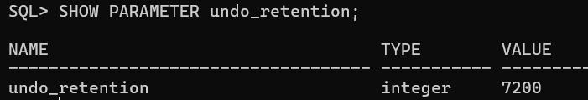
(b) Flashback Version Query Setup and Execution
Step 1: Connect as HR
Step 2: View current salary
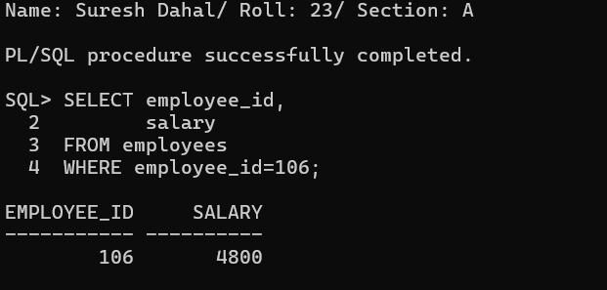
Step 3: First update
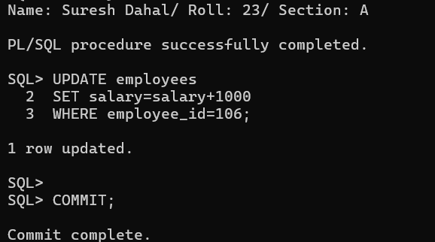
Step 4: Second update
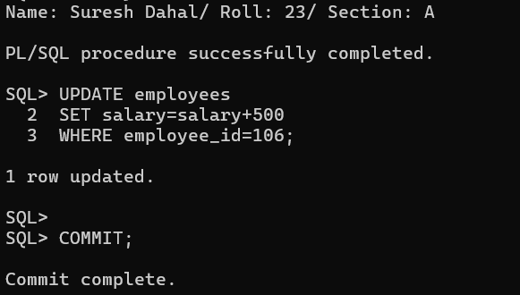
Step 5: Delete the row
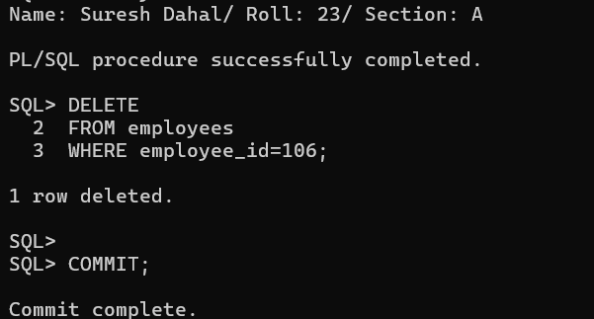
Step 6: Display all versions
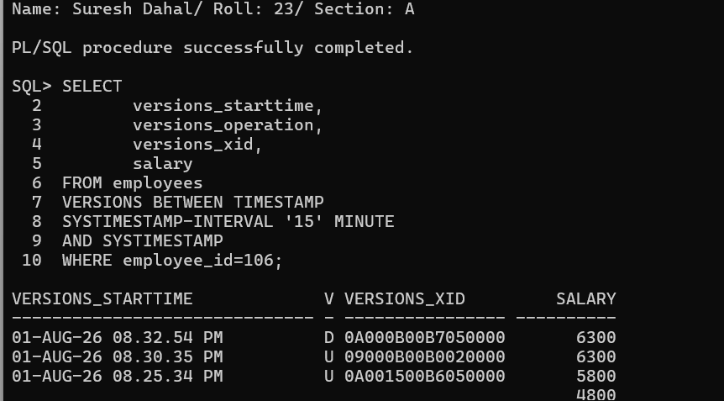
(c) Analysis of Version Query Results
Step 1: Identify the transaction ID
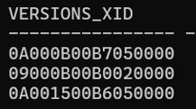
Step 2: Restore the deleted row
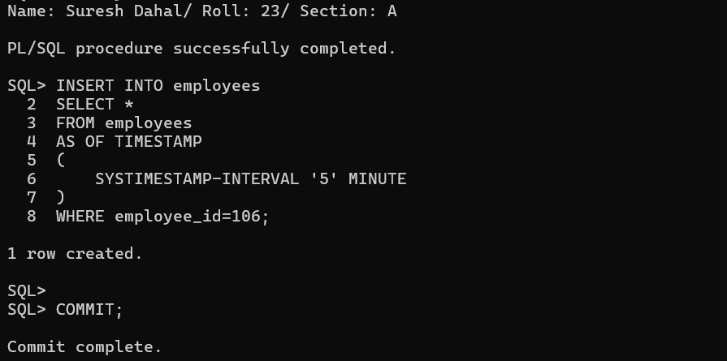
Step 3: Verify restoration
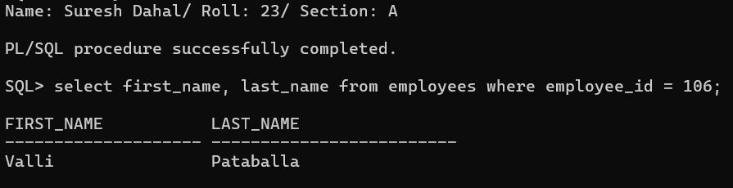
(d) Flashback Transaction Query Setup and Execution
Step 1: Perform a transaction
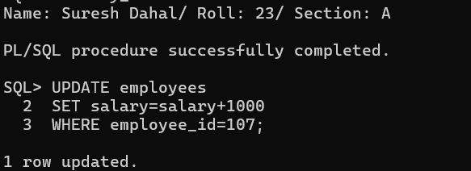
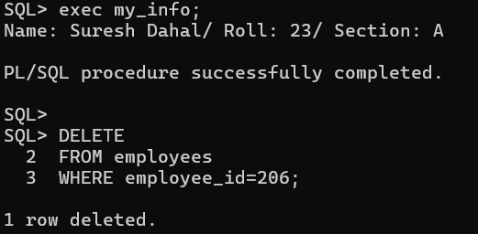
Step 2: Obtain the transaction ID before committing
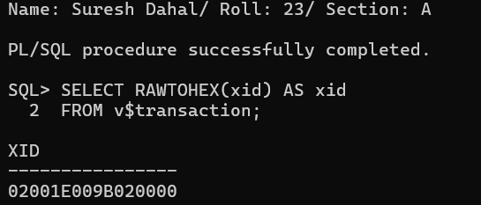
Step 3: Commit the transaction
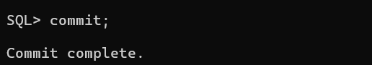

Step 4: Query Flashback Transaction Query
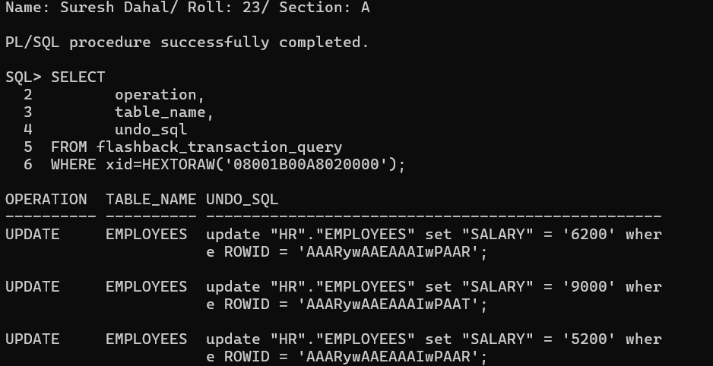
(e) Reversing Changes with Transaction Query
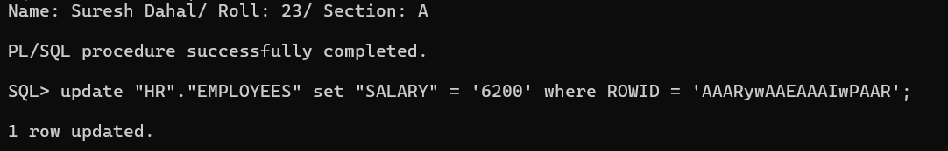
Verify the changes
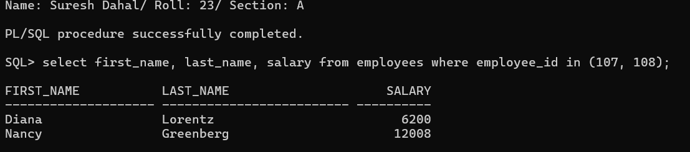
(f) Validation and Advanced Scenario
Step 1: Attempt a Version Query beyond available undo history
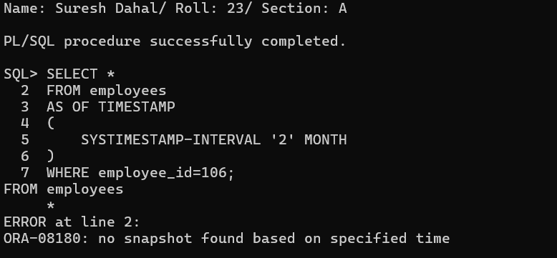
Step 2: Perform a larger transaction
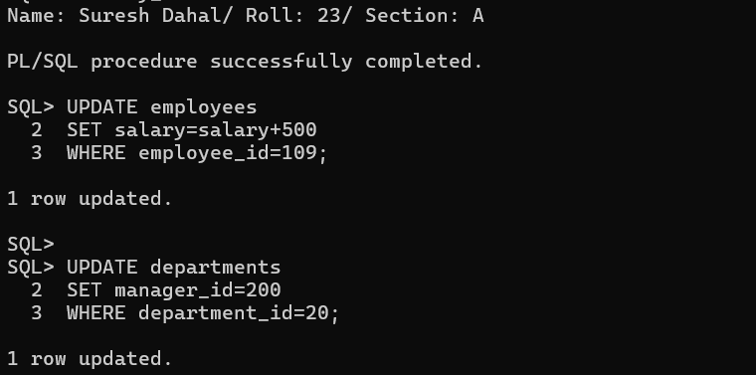
Step 3: Obtain the transaction ID
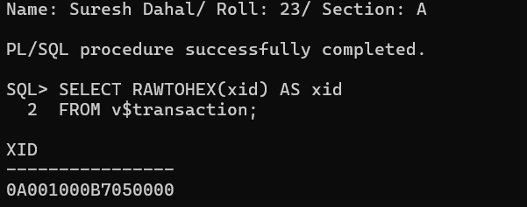
Step 4: Commit
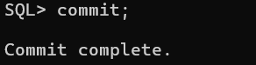
Step 5: Query transaction information
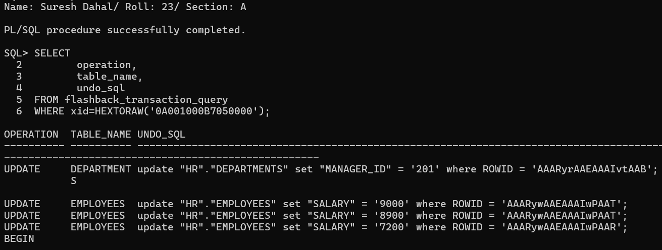

Step 6: Execute the generated UNDO_SQL statements
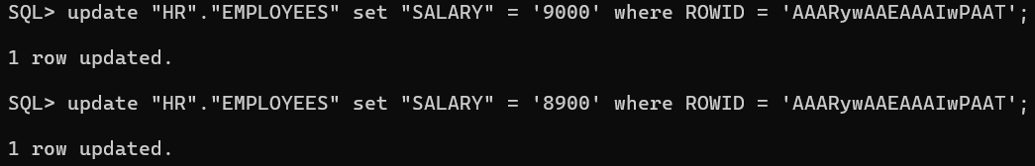
Step 7: Verify
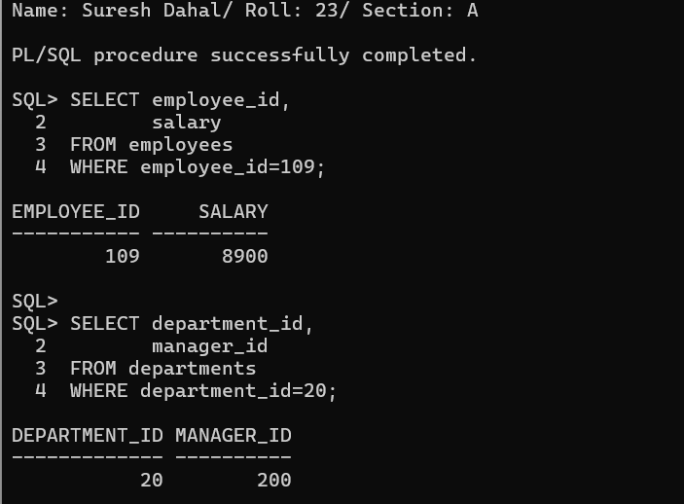

16. AUTOMATIC WORKLOAD REPOSITORY (AWR) IN ORACLE 19C
OUTPUT
(a) Preparation and Configuration
Step 1: Connect to Oracle as SYSDBA
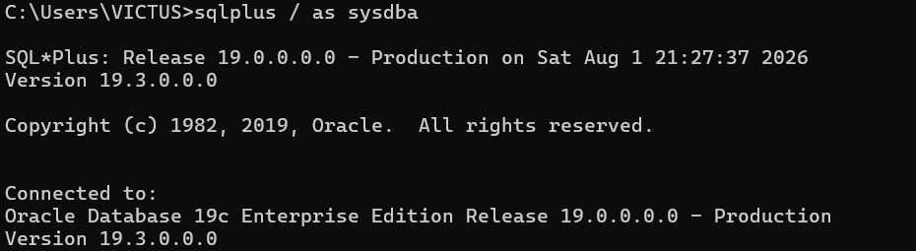
Step 2: Verify AWR parameters
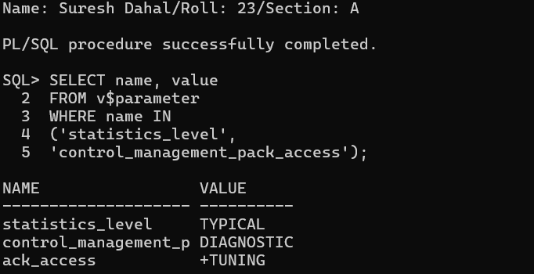
Step 3: Modify parameters
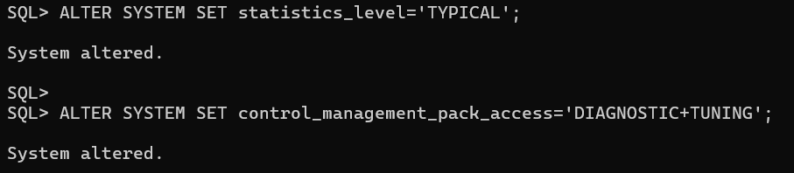
Step 4: Check the default snapshot interval
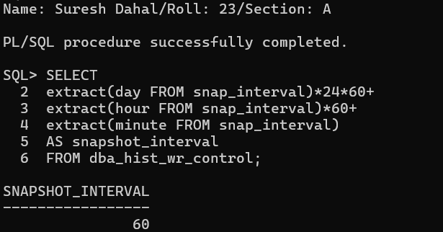
(b) Create Baselines with Snapshots
Step 1: Create the first AWR snapshot
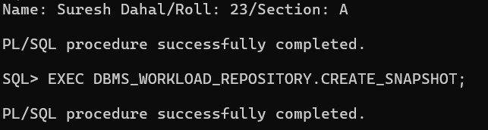
Step 2: Connect as HR
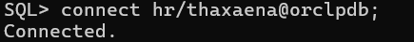
Step 3: Generate workload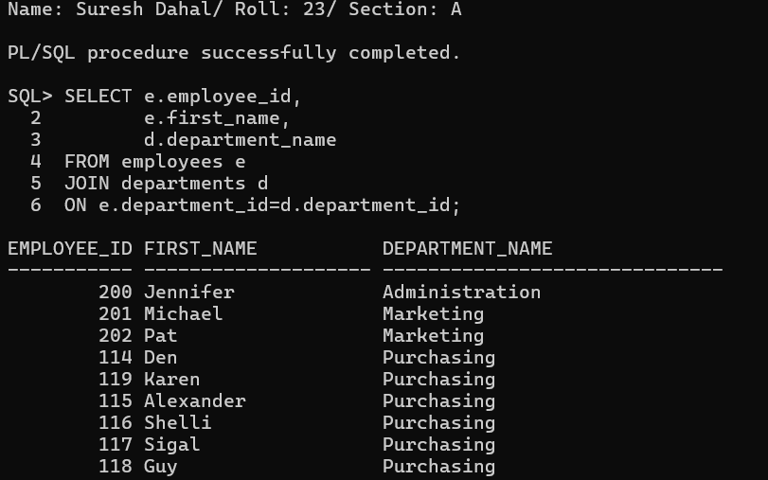
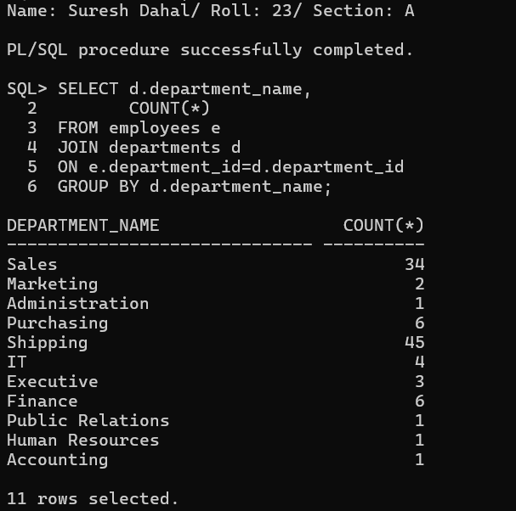
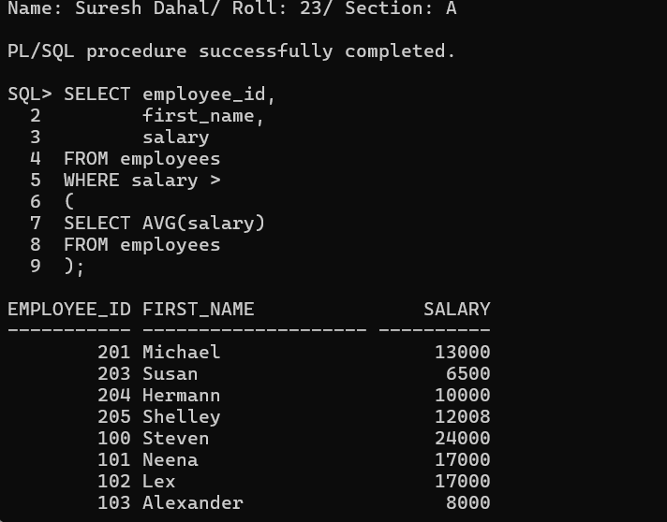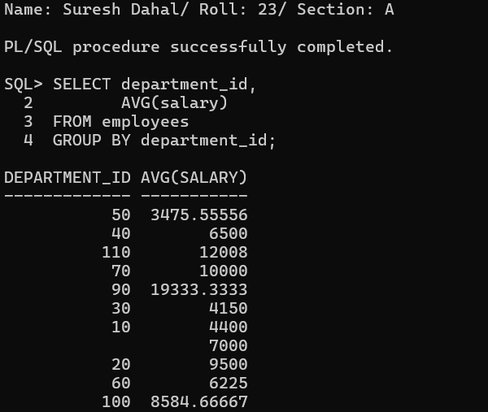
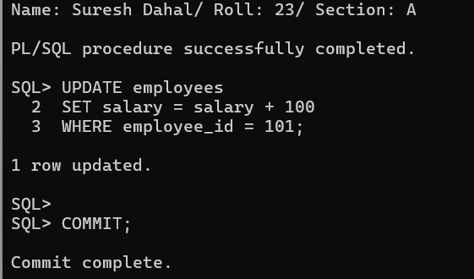
Restore the original salary.
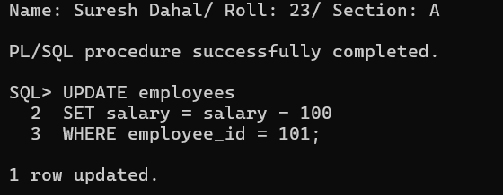
Step 4: Create the second snapshot
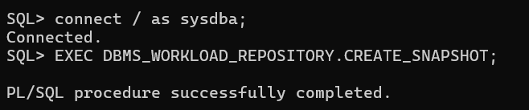
Step 5: View available snapshots
Display all snapshots.
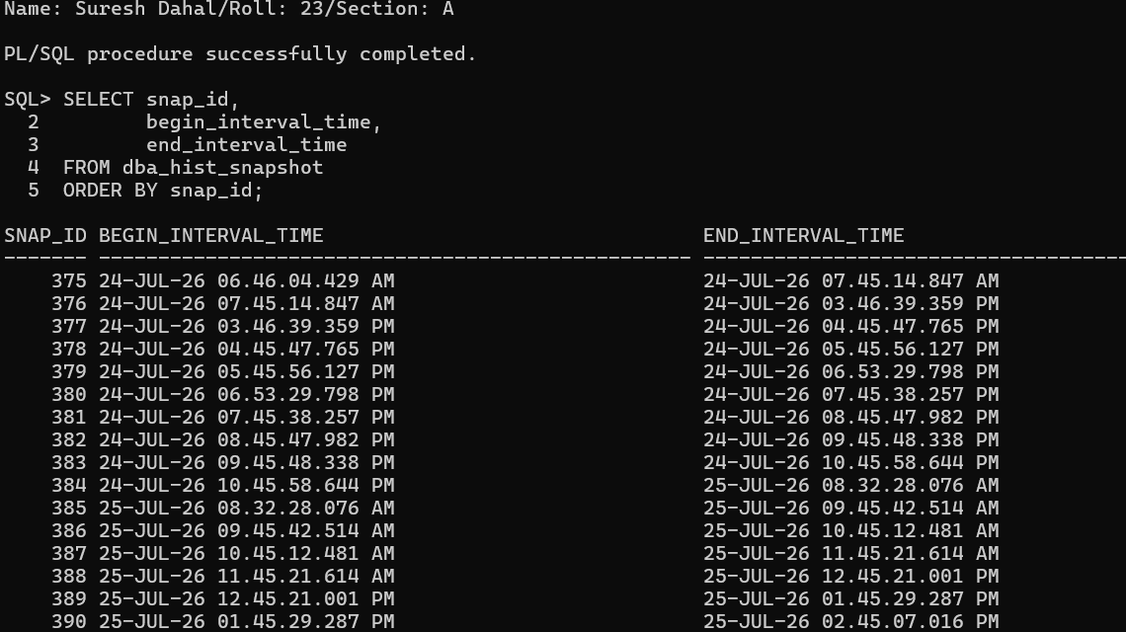
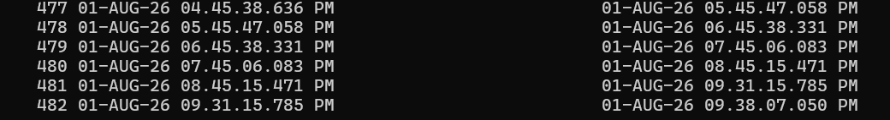
(c) Generate AWR Report
Step 1: Run the AWR report script
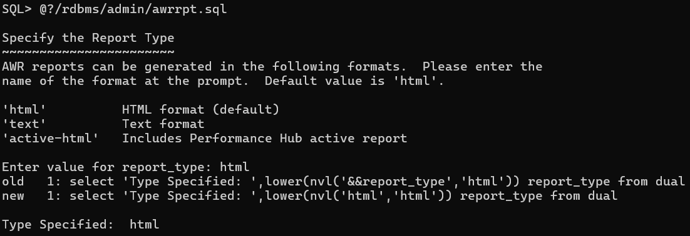

Step 2: Select report type
Step 3: Specify the number of days
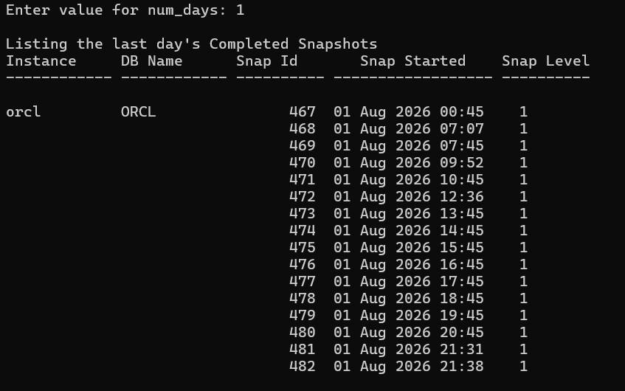
Step 4: Enter Begin Snapshot ID
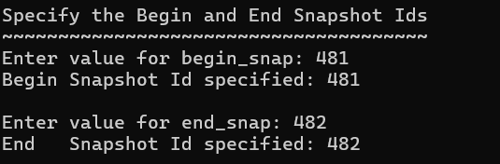
Step 5: Enter End Snapshot ID
Step 6: Specify the report name
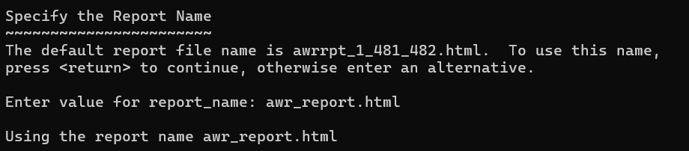
Step 7: Open the generated report
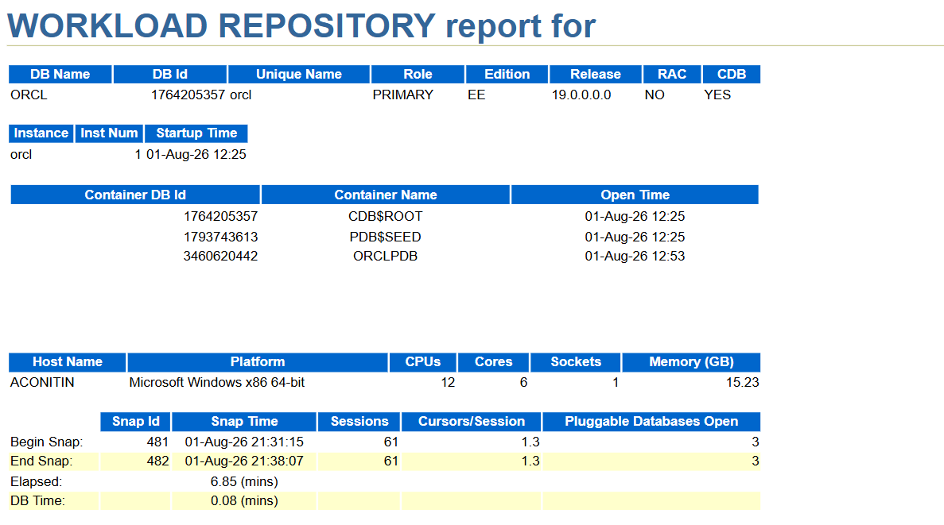
(d) Analysis of AWR Report Sections
1. Instance Efficiency Percentages
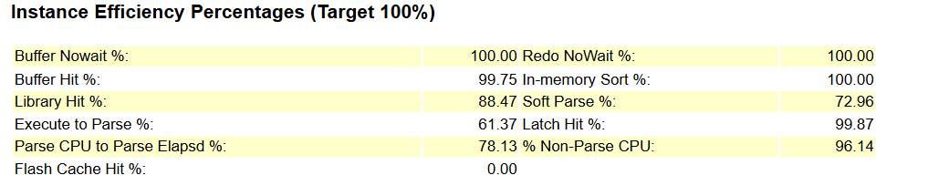
2. Top Timed Foreground Events
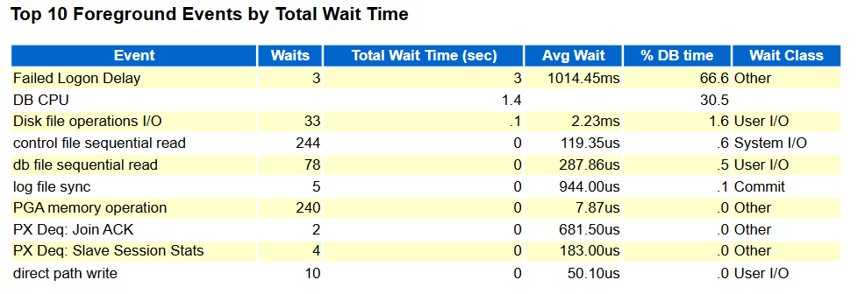

3. SQL Statistics
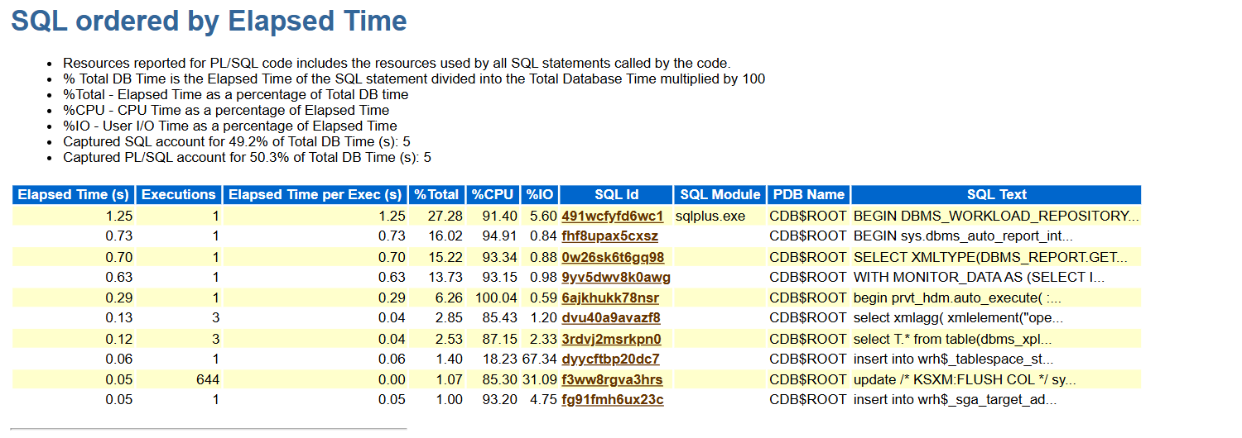

4. Performance Analysis and Optimization
